118 South H St., Livingston Offered at $415,000 - ML #233203
Classic 4 bedroom, 2 full bath Victorian property with the elegance of the early 20th century yet remodeled with all modern conveniences and bathed in a naturally lit architecture, located on desirable South H Street.

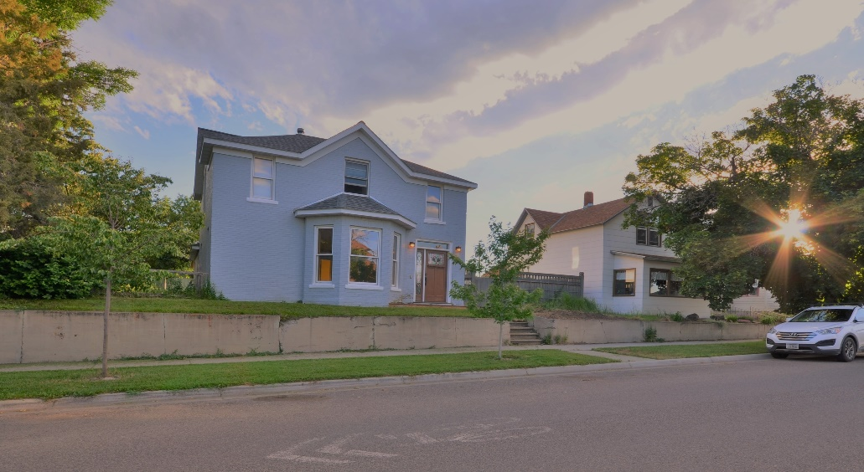
The large lot is two and a half city lots with a charming and functional ADU (guest house in the back). Excellent off-street parking for several vehicles or boat, trailer, camper. One car garage or shop for when the weather turns. Easy walking distance to Shane Center, Downtown, G St. Park and the Yellowstone River.

These are just some of the amenities:
- Radiant heat throughout fist and second floors, newly poured basement is plumbed for radiant heat.
- Vermont Castings Wood Stove heats the whole downstairs and most of upstairs.
- Refinished hardwood floors downstairs, wall-to-wall carpet upstairs, fresh paint.
- Large, open skylight lit kitchen with stainless cabinet depth fridge/freezer, freezer on bottom.
- Dual fuel stainless range, gas burners, electric oven.
- Marble counter insert for bread, pastry or other specialty creation.
- 200-amp electric service, completely rewired with 3 wire Romex.
- Completely replumbed, central vacuum, clawfoot tub, tile shower.
- Established garden with berries, herbs, apple tree, tool shed.
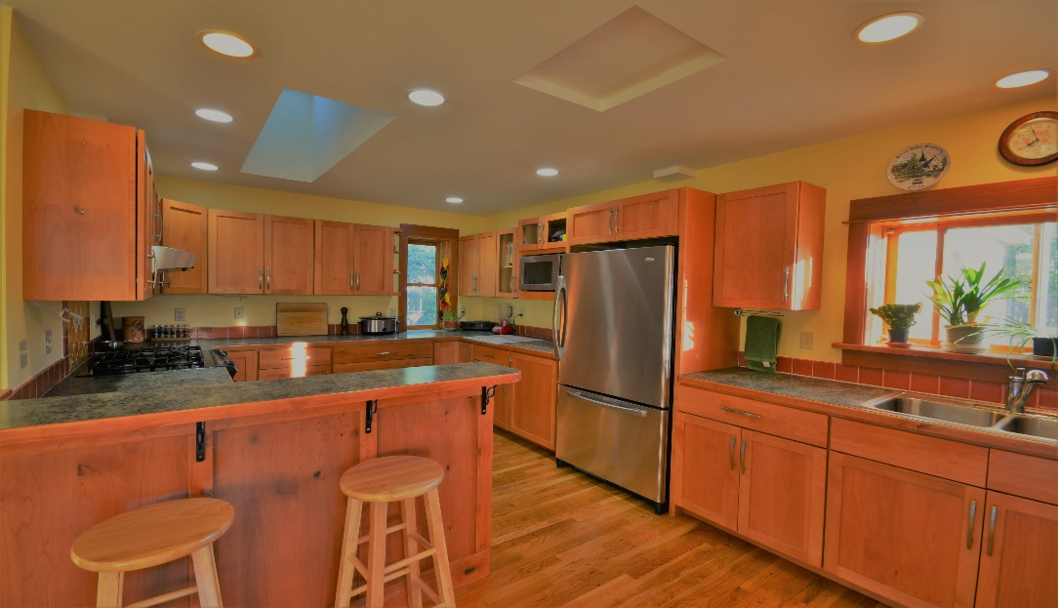

Call/text Alex Russell, Realtor 406-580-5047
Email russella17@gmail.com
McCaw & Company Real Estate, Broker

